Week 7 Bias DAC Progress
October 11, 2026 | October 6 mentor feedback follow-up
Team Member: Henan | Week 7 | October 11, 2026
Course: AMS Senior Design | Project: Programmable Bias Voltage DAC

Selected block: Capacitor DAC array
This week: explained the enabled Ron peak, reconstructed the major-carry dip, extracted nominal INL/DNL, and screened 12-bit area.

Question 1
Based on the overall specifications you set for your project, what specifications should this block meet?
The current 3-bit array should produce eight ordered levels from 0 to 875 mV with a 1 V reference span and 125 mV LSB. Provisional future 12-bit targets in specs v0 revision 2 are |INL| <= 1 LSB, |DNL| <= 0.5 LSB, room-temperature request-to-settle <= 10 us within 61 uV, and hold drift <= 61 uV over 1 ms. These targets are not mentor-approved or demonstrated by the present nominal 3-bit tests.

Question 2
What simulations do you need to run to verify this block meets those specifications?
Completed: enabled TG DC sweep and NMOS/PMOS operating-point comparisons; 000 to 001 overshoot measurement; 011 to 100 bottom-plate inspection, weighted reconstruction and residual; fixed-delay eight-code extraction. Peak Ron is about 20.84 kOhm from the midrange currents. Maximum endpoint |INL|/|DNL| are 6.32e-5/8.85e-5 native 3-bit LSB. Pending: other isolated-bit/reverse transitions, convergence, hold/load, noise, power, PVT, mismatch and PEX.

Question 3
Why is this block a proper selection for your application and your overall specifications?
The capacitor array and six MOS TGs form a reusable charge-redistribution prototype with automated code control. Week 6 established full-code operation; Week 7 separated sampled linearity from switching disturbance. Cryogenic usefulness depends on reference/load interfaces, leakage, noise, power and validated cold models. Multi-channel sample-and-hold is a possible companion block, but it has not been built.

Question 4
What are the main challenges in designing this block?
Both TG devices have insufficient midrange overdrive at 1 V; body bias further raises threshold magnitude. The 011 to 100 output dips to about 243.21 mV as the lower-bit bottom plates fall before the MSB contribution catches up. Its underlying drive/load/injection contributions remain open. Direct 12-bit scaling also increases capacitor count and geometric area substantially.

Question 5
What circuit- or system-level solutions address those challenges?
Preserve the baseline while the mentor reviews switch drive/device choices. The weighted bottom-plate reconstruction explains the observed output waveform, but does not exclude charge injection already present on those nodes. Defer the proposed b2 TG-strength test. Future implementation candidates are a physical reset, nonoverlap control and hold/refresh support; the two-channel hold schematic was discussed but explicitly postponed. Assess the need for a buffer before connecting storage capacitors to the floating CDAC output.

October 6 mentor feedback closure
Item | This week and next action
Ron peak | Investigated: occurs while enabled. Review device/drive options and settling implications.
Disturbance | Partly addressed: 000→001 overshoot 21.27 mV; major-carry reconstruction agrees. Other isolated bits and root-cause comparisons remain.
INL and DNL | Initial extraction complete with a consistent delay and endpoint convention. Convergence and robustness remain.
Cryogenic submodules | Scope discussed: reset/control, hold/refresh, reference and buffer. No new module implemented.
12-bit area | 4096 unchanged units: 453.259 pF and 0.4096 mm² sum of W×L. Actual layout footprint and area budget pending.
Mentor decisions for October 13: switch device/drive direction; acceptable array/core area; actual load, voltage range and cold-model availability; priority of DAC-internal versus companion submodules.
Confirmed October 11 conditions: tt_lib, 27 C, 1 V supply/reference span, and no added CDAC output load. The array uses eight 110.659 fF units and six MOS TG reference switches; reset and references remain ideal, with Verilog-A control.

Enabled TG resistance investigation
October 11, tt_lib at 27 C: the peak occurs with EN = VDD = 1 V and ENB = VSS = 0 V held constant. A = vtest and B = vtest + 1 mV; DC sweep 0 to 0.999 V in 0.01 V steps. Ron = 0.001 / abs(I(V2/PLUS)). NMOS W/L = 1 um/60 nm; PMOS = 2 um/60 nm; each has one finger and multiplicity one.
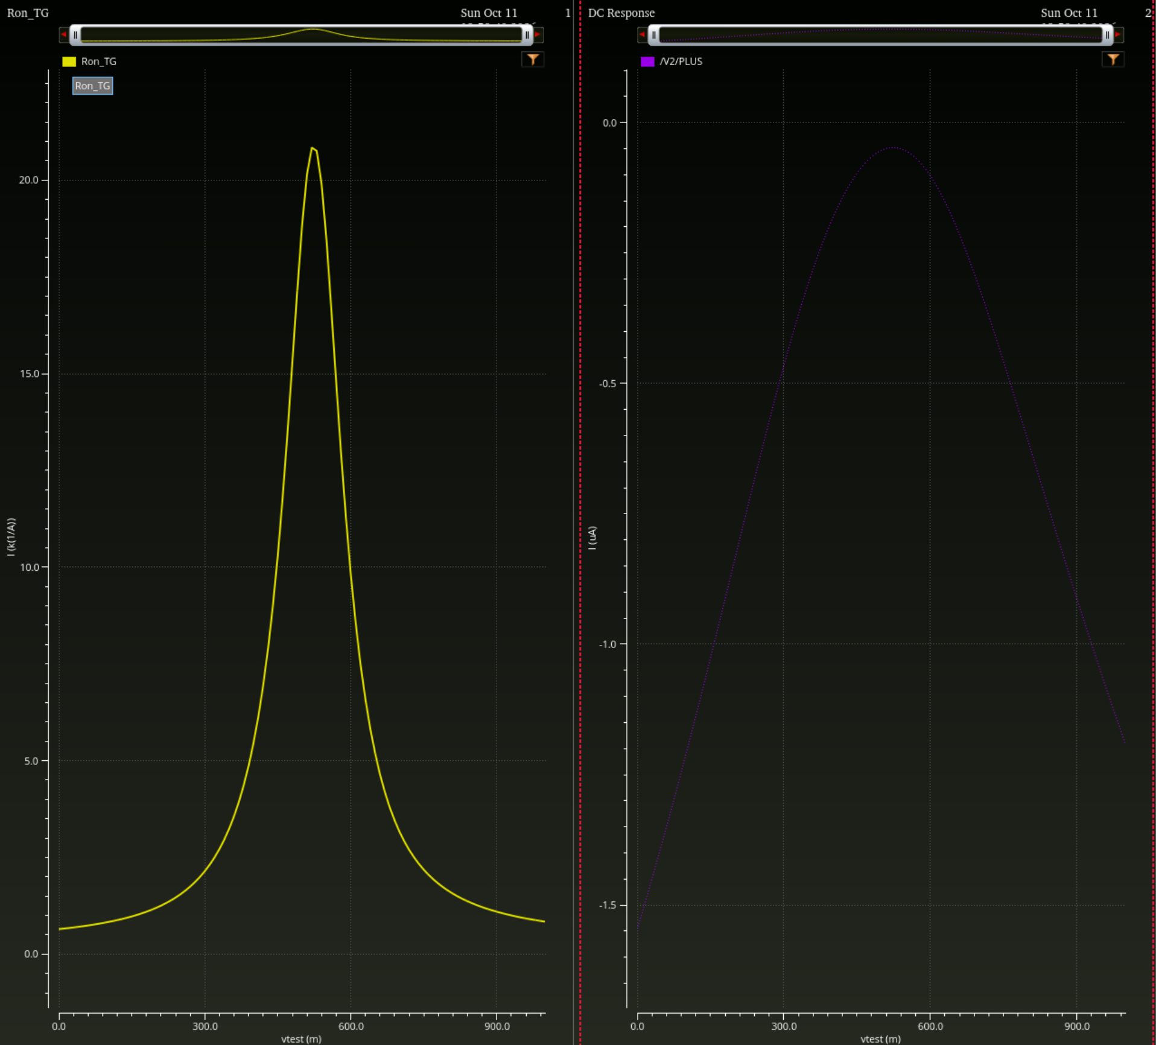
Enabled DC sweep. The peak near 0.52 V is approximately 20–21 kOhm; it is not a control turn-off event. The current plot uses microamperes.
Device at vtest = 0.52 V | Vgs (mV) | Vth (mV) | Vbs (mV) | Id (nA)
NMOS | 480 | 654.5 | −520 | 25.65
PMOS | −521 | −644.6 | 479 | −22.33
Both devices are below their reported thresholds. Summing current magnitudes gives 47.98 nA, corresponding to 20.84 kOhm. At the rail comparisons, NMOS Vth = 601.4 mV and |Id| = 1.546 uA; PMOS |Vth| = 575.4 mV and |Id| = 1.19 uA. Reduced gate overdrive dominates the midrange concern; reverse body bias adds a threshold increase.
Decision pending: retain the baseline and review device family, gate drive and sizing with the mentor. These data do not by themselves establish failure of the DAC settling specification. The displayed PMOS endpoint current is +1.19 uA; its sign convention remains to be checked.

Switching disturbance and sampled linearity
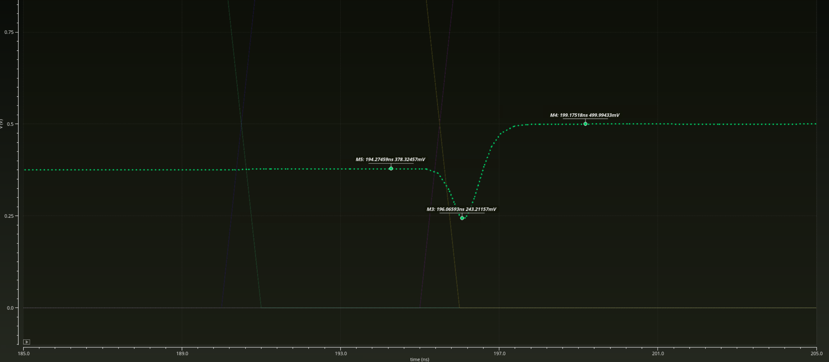
October 11, 011 to 100: break at 190 ns, make at 195 ns. Near-minimum marker: 243.21157 mV at 196.06593 ns, approximately 131.79 mV below ideal code 011. This is a sampled local minimum, not a converged peak search.
At 196.0659 ns, bottom plates b0/b1/b2 are 173.7483/436.5179/224.7282 mV. Their weighted sum (b0 + 2b1 + 4b2)/8 = 243.2121125 mV agrees with Vout = 243.2116 mV to about 0.51 uV at displayed precision. The whole-window residual is visually about −4.9 to −0.5 uV. Unequal bottom-plate trajectories account for the dip; their physical cause is not yet isolated.
Code | t (ns) | Vout (mV) | Error (uV) | INL (LSB) | DNL (LSB)
000 | 60 | ~0 | ~0 | 0.00e+00 | —
001 | 100 | 124.995486 | -4.514 | -3.27e-05 | -3.27e-05
010 | 140 | 249.995979 | -4.021 | -2.53e-05 | 7.39e-06
011 | 180 | 375.006612 | +6.612 | 6.32e-05 | 8.85e-05
100 | 220 | 499.995980 | -4.020 | -1.84e-05 | -8.16e-05
101 | 260 | 624.995510 | -4.490 | -1.87e-05 | -3.10e-07
110 | 300 | 749.997581 | -2.419 | 1.35e-06 | 2.00e-05
111 | 340 | 874.996981 | -3.019 | 0.00e+00 | -1.35e-06
Driver: reset release 20 ns, first break 30 ns, 40 ns code interval, 5 ns dead time, 1 ns edges; stop 400 ns. Samples: t = 60 + 40k ns, 25 ns after each scheduled make. Error is relative to k × 125 mV. Endpoint step L = (V7−V0)/7 = 124.999568714 mV; INL(k) = (Vk−V0−kL)/L; DNL(k) = (Vk−V(k−1))/L−1. Both use the same endpoint normalization.
Maximum |INL| = 6.32e−5 LSB (011); maximum |DNL| = 8.85e−5 LSB (010 to 011). All sampled steps are positive. These are finite-delay nominal results; hold-window stability, timestep/tolerance convergence, mismatch, PEX and cryogenic operation remain unverified.

